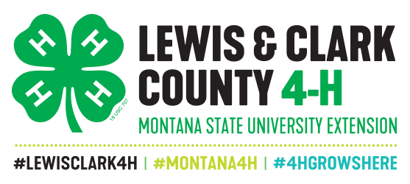
National 4-H Week Window Display Contest

First full week of October each year

National 4-H Week is a time of year to promote and make the public aware of the attributes and importance of the 4-H program in our community. Each club is encouraged to put up a window display visible in the community to promote Lewis & Clark County 4-H. You can choose any theme you’d like, but please use the following slogans/hashtags when possible:

- I ♥ 4-H
- #National4HWeek
- #TrueLeaders
- #4HGrown
- #Opportunity4All
- #4H
- #lewisclark4h
- Making the Best Better
- Head, Heart, Hands, Health
- 4-H Grows Here

PRIZES:
1st Place -$75.00 2nd Place - $50.00 3rd Place - $35.00 RULES:
- One window display per club will be judged. Club members need to contact a business to make arrangements for their window display.
- Window display expenses are absorbed by each club.
- Displays must be completed in windows by the Sunday morning of National 4-H Week and not taken down before Saturday at the end of the week.

Points:
 | a. Accurately and clearly depicts 4-H | 10 points
 | b. Contains Club Info/How to Join | 10 points
 | c. Display is organized and clear | 10 points
 | d. Display is creative and appealing | 10 points
 | e. Contains 1+ hashtags/slogans  TOTAL | 10 points  50 POINTS
It is recommended that the display include club name, meeting time, meeting location and contact person for new member recruitment.
……………………………………………………………………………………
Return submission and email photos of the display to the Extension Office by the Monday of National 4-H Week
100 West Custer, Helena, MT 59602 or lewisclark@montana.edu

CLUB NAME

CLUB CONTACT PERSON PHONE

WINDOW DISPLAY LOCATION

